
Wynnbrook Christian Preschool Registration Form
Child’s Age on September 1, 2025: _________
Child’s Grade on September 1, 2025: _________

PREFERRED NAME: CHILD’S FULL NAME:

First: ________________________ Last: __________________________

DATE OF BIRTH: ______ / ______ /______ Male or Female _______

PARENT/GUARDIAN #1 Name: __________________________________________________________

Cell #: _____________________ Email: ____________________________________________________

Home Address: _______________________________________________________________________
Street City State Zip

Employment: ________________________________ Work #: _________________________________

PARENT/GUARDIAN #2 Name: __________________________________________________________

Cell #: ___________________ Employment: __________________________ Work #: _____________

ADDITIONAL INFORMATION ABOUT YOUR CHILD:

Siblings: (names and ages) ___________________________________________________________

Allergies: ____________________________________________________________________________

Please give any additional information that might be important for your child’s teacher to know:

_________________________________________________________________________
(other than parent/guardian listed above)
EMERGENCY CONTACT INFORMATION:
Name | Phone Number | Relationship to child

PERSON(S) AUTHORIZED TO PICK UP CHILD: (other than parent, guardian, and/or emergency contact)
Name | Phone Number | Relationship to child

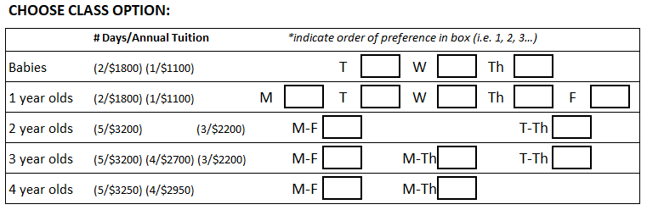

PLEASE READ AND INITIAL THE FOLLOWING:

In the event of an illness or accident that requires immediate treatment at a time when a parent cannot be located, I give permission for the Director, Wynnbrook Baptist Church or other center personnel designated by the Director, to authorize treatment. I will not hold this center or medical personnel responsible. This is done with the understanding that every attempt will have been made to contact the parents and other people listed for emergency contact.

I understand that the payment of the registration fee assures that my child has a place in this program. I understand that the Registration Fee is non-refundable. We require one month’s advance notice if you intend to withdraw your child from the program.

I understand that it is a requirement for my child to be potty trained to attend the three-year-old and four-year-old programs.

PICTURE RELEASE INFORMATION:

I give my permission for Wynnbrook Christian Preschool to (Circle YES or NO):

YES / NO Publish my child’s picture on Facebook or Instagram. Names will not be published.

YES / NO Allow my child’s teacher to take and use my child’s picture for classroom purposes, including classroom communication apps which are limited only to parents of students enrolled in the class.

YES / NO Allow my child’s picture to be used to promote Wynnbrook Christian Preschool, such as our school brochure.

Please mail/Email correspondence to:

Wynnbrook Christian Preschool
500 River Knoll Way
Columbus, GA 31904

706-323-8485
DirectorWCP@wynnbrookbaptist.com

FOR OFFICE USE ONLY
CHECK CASH

Check # _____________

Amount ____________ Date ____________

